Clearing SCCM Cache: (This is the same for all collection groups)

Navigate to Client Information: Assets and Compliance/Overview/Device Collections/Server Systems/Patch Groups/Server Dev Group 1 (example)/right-click – Right Click Tools/Client Tools/Client Information

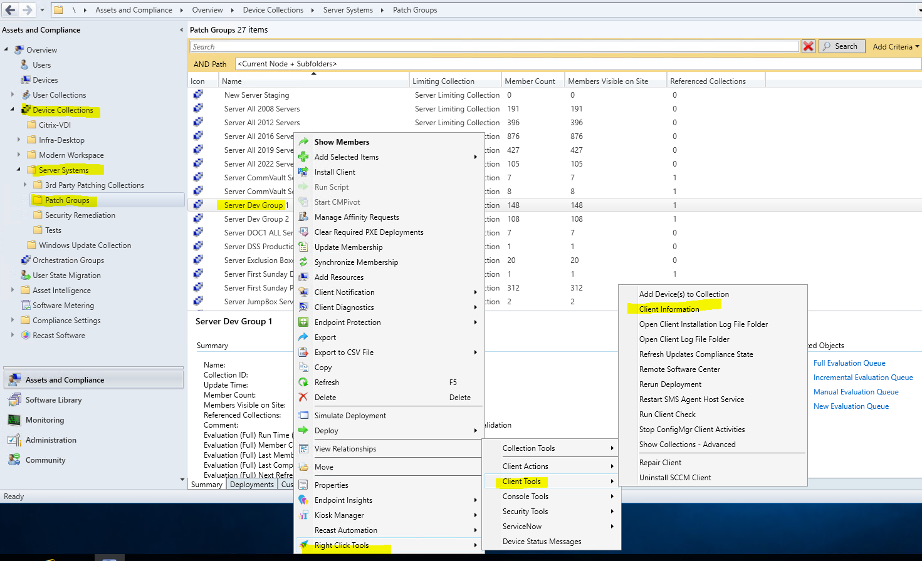

Click on the Cache tab/Check the boxes/Clear Cache

